**LEAD SCORING :**

**Turi Use case :** <https://www.kaggle.com/c/airbnb-recruiting-new-user-bookings>

The inability of marketing to identify and hand over the best opportunities in time to the sales team is what causes most lost opportunities, and the ever-prevailing tiffs between marketing and sales. The solution is – **LEAD SCORING.**

*Lead scoring is valuing your leads based on their demographic, firmographic and behavioral data*. Simply put, you qualify your opportunities based on whether or not they fit the persona of your target audience, and how engaged are they with your business (their response to your email campaigns, their activities on your website etc.), and their position in your sales cycle.

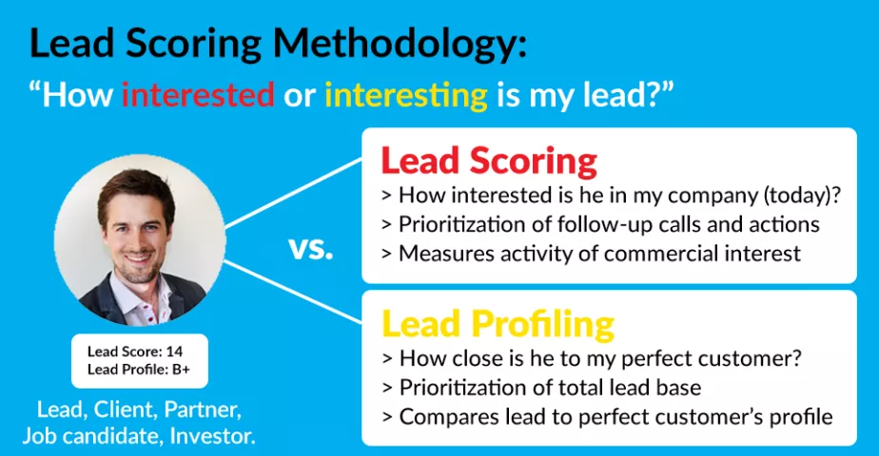

To understand **Lead Scoring** better, think of key interactions that would factor into shaping a Lead Score. What actions taken by a lead would indicate they are deserving of your attention?

* Visits your website repeatedly
* Visits pricing page
* Does not visit jobs page every time he comes (unless lead scoring is used by HR department)
* Looks at a slide deck
* Downloads documents
* Clicks on links in your emails
* Visits contact page

**APPLICATIONS :**

## **Lead Scoring for Marketing:**

**Benefits for Marketing Managers:**

* Qualitative segmentation of large contact databases
* Better qualification of leads before information transfer to sales
* Timely communication to most active leads

## **Lead Scoring for Sales Management:**

**Benefits for Sales Managers:**

* Higher deal closing rate by reaching out to low hanging fruit
* Higher productivity thanks to efficient prioritization
* Less lost opportunities thanks to “hot lead” alerts

# **Why Mergers Are The Perfect Use Cases For Predictive Lead Scoring :**

Have you been a part of a merger or acquisition? Was the newly combined company pleased with the results, or did they disappoint? What was the success rate of finding existing customers to cross-sell the newly acquired products or services? How were those targets selected?

The problem begins with an unscientific targeting process. Typically, company A acquires company B. Company A, the bigger company, ingests the employees of company B and forms a group chartered with cross-selling company B’s products to company A’s customers and vice versa. Sales teams gather and produce lists of targets for the cross selling. The sales results are almost always below expectations because the targeting is done without data to justify the target selections.

Enter predictive lead scoring, a data driven approach to discover your ideal customer’s DNA, target the customer and engage with the best message and channel. [Predictive lead scoring](http://www.mintigo.com/predictive-lead-scoring/) is a perfect antidote for sub-par cross-selling after a merger or acquisition.

You’ll know which products fit which customers and you can provide the most relevant offers and messages in your campaigns. Through the use of predictive lead scoring, mergers and acquisitions can truly meet the strategic objectives of boosting revenue thru cross selling based on data driven techniques.

**USE CASE :**

### **Business challenge :**

* Leading used car sales company makes offers to customer prospects based on information acquired through an older, inaccurate lead scoring system
* Customers who are not likely to buy are often targeted, resulting sub-optimal use of resources and missed opportunities

### **Solution :**

* Utilized customer profile information and web site usage data to create an accurate lead scoring system
* Identified variables that best predict the likelihood of purchase

### **Business benefit :**

* Targeting efforts are used on customers where they are most likely to be effective, improving efficiency and return

## **Look Beyond *Lead Scoring* – Engagement Scoring**

However, there would be certain cases, where only lead scoring would not be enough. For instance, if in your database, there are 2 leads, with identical lead scores of 250, however, with drastically different ages, with Lead A being 7 days old, and lead B being 100 days old. Your sales team would not be able to identify the sales ready lead just by looking at the lead score here.

A concept more advanced than lead scoring comes into picture now – Engagement Scoring. Engagement scoring typically considers recency of your engagement related activities, in addition to their lead scores.

Let me specify how that would go down. Your engagement score is calculated based only on engaging activities, and a timeline that you specify, say past 30 days. So, the lead activities of only the past 30 days are being used to calculate your engagement score. So, you immediately know by looking at the engagement scores of these 2 leads (Lead A = 100, Lead B = 0), that Lead A is the one that is probably interested in buying from you.

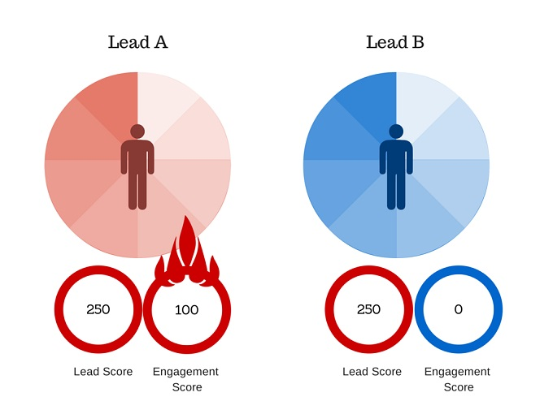

**Use Links :**

<https://blog.leadsquared.com/mining-the-real-gems-from-your-data-lead-scoring-and-engagement-scoring/>

<https://www.periscopedata.com/blog/simple-lead-scoring-with-enrichment>

<http://www.mintigo.com/predictive-lead-scoring/>